**Nitride film 0 MT-455**

Ragula Bhoopal

20ETMM11

Group-2

**Aim:** To determine crystallite size and lattice strain for the given data.

**Procedure:**

Given the instrumental broadening value,

Gaussian equation 

 where, $η=S\text{train in the material}$ $$\text{L= Crystallite Size} \\ \text{k=0.94}$$

$λ=0.154nm$

Comparing the above equation with  Where, 

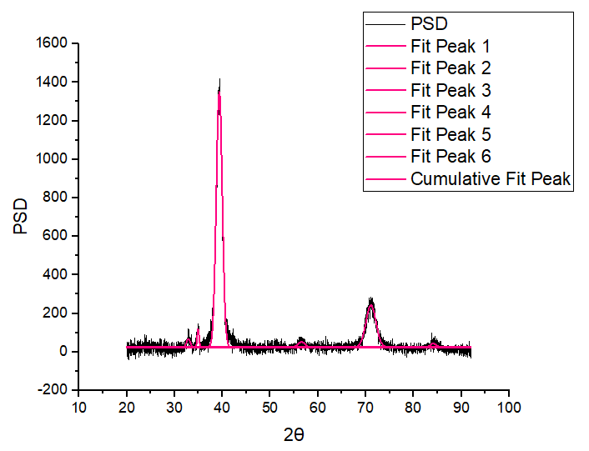

|  |  |  |  |  |  |  |  |
| --- | --- | --- | --- | --- | --- | --- | --- |
| **2θ** | **θ(rad)** | **Bo(fwhm)** | **Bo(rad)** | **Bo2** | **Bi(deg)** | **Bi(rad)** | **Bi2** |
| 32.89235 | 0.28704 | 0.91439 | 0.015959 | 0.000255 | 0.045 | 0.000785 | 6.1685E-07 |
| 34.91805 | 0.304717 | 0.45754 | 0.007986 | 6.38E-05 | 0.045 | 0.000785 | 6.1685E-07 |
| 39.34331 | 0.343335 | 1.47026 | 0.025661 | 0.000658 | 0.045 | 0.000785 | 6.1685E-07 |
| 56.53556 | 0.493366 | 1.68187 | 0.029354 | 0.000862 | 0.045 | 0.000785 | 6.1685E-07 |
| 71.0858 | 0.620341 | 2.44668 | 0.042703 | 0.001824 | 0.045 | 0.000785 | 6.1685E-07 |
| 84.1166 | 0.734056 | 1.46242 | 0.025524 | 0.000651 | 0.045 | 0.000785 | 6.1685E-07 |

|  |  |  |  |
| --- | --- | --- | --- |
| **Br2=Bo2-Bi2** | **Br** | **Brcosθ** | **sinθ** |
| 0.000254077 | 0.01594 | 0.015288 | 0.283114 |
| 6.31526E-05 | 0.007947 | 0.007581 | 0.300024 |
| 0.000657864 | 0.025649 | 0.024152 | 0.336629 |
| 0.00086105 | 0.029344 | 0.025844 | 0.473593 |
| 0.001822897 | 0.042695 | 0.03474 | 0.581312 |
| 0.00065086 | 0.025512 | 0.018942 | 0.669886 |

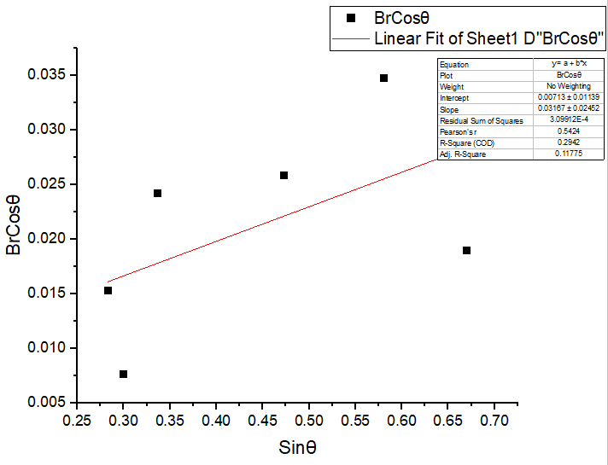

|  |  |
| --- | --- |
| Equation | y = a + b*x |
| Plot | BrCosθ |
| Weight | No Weighting |
| Intercept | 0.00713 ± 0.01139 |
| Slope | 0.03167 ± 0.02452 |
| Residual Sum of Squares | 3.09912E-4 |
| Pearson's r | 0.5424 |
| R-Square (COD) | 0.2942 |
| Adj. R-Square | 0.11775 |

$$b=Slope=η \\ a=Intercept=\frac{kλ}{L} \\ Therefore, η=0.03167 \\ \frac{kλ}{L}=0.00713 \\ L=\frac{kλ}{0.00713} \\ L=\frac{0.94×0.154}{0.00713} \\ L=20.3029\text{ nm}$$

**Result**

$$η=S\text{train in the material=}0.0316 \\ \text{L= Crystallite Size}=20.3029 \text{nm}$$